**Analysis on some Basic Commands related to System Infrastructure:**

1. **ipconfig:**

This command gives a list of ip configuration details based on a particular OS you are using. It helps to view the IP address, network mask, and gateway for all physical and virtual network adapters.

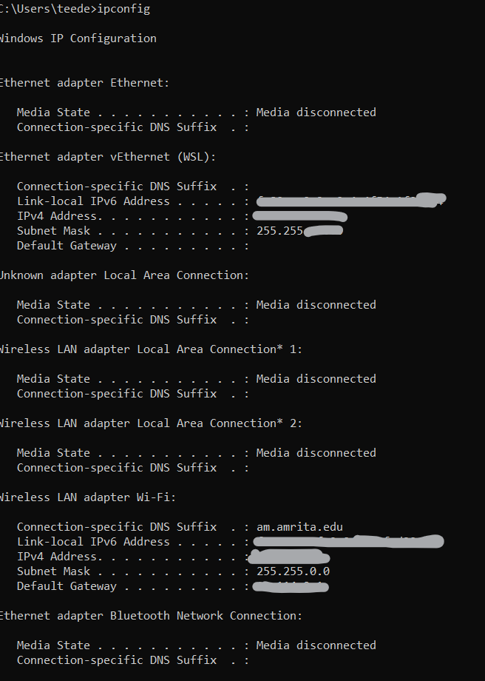

1. **nslookup:**

This command allow us to find information or records on a specific domain name or server including access to view all type of records (NS,MX,text,SOA,TXT etc,.).

It can also be used to look for the domain name associated with an IP address as well. This command has two modes:interactive and noninteractive.

While in interactive mode allow us to look up more than one piece of data whereas the non-interactive mode allows only for to issue single queries.

Here, I have used youtube server to for nslookup and we found the addresses of the server domain only.

Then we can do nslookup using their Ip addresses for the servers in the step such to collect more records until we find a loophole of a particular server.

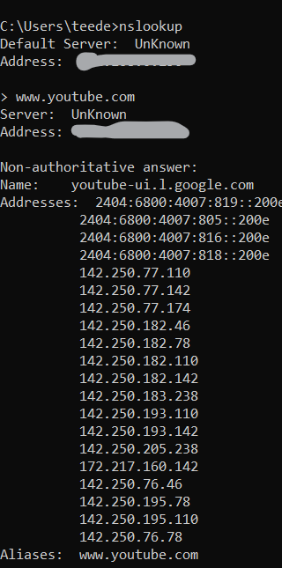

1. **tracert:**

This command displays details about the path that a packet(Internet protocol) takes to the destination(server or ip_add) we pick from our device. Hence, the Trace route is shortened into the tracert.

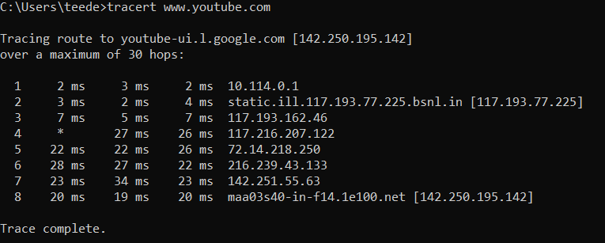

1. **ping:**

By using ping command, you can determine whether a remote destination IP is active or inactive which also helps us to verify that a computer can communicate with another computer/network device or not.

It also provides us as a tip to find the round-trip delay in communicating with the destination and check whether there is a packet loss.

This command sends Internet Control Message Protocol (ICMP) echo request messages to the destination computer and waits for a response.

Then it shares how many of those responses are returned and how much long does it takes for them to return.

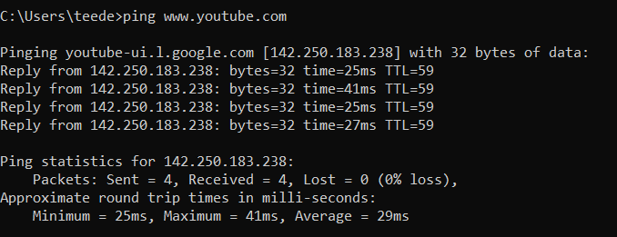

1. **arp:**

This Command is a TCP/IP utility used for viewing and modifying the local Address Resolution Protocol (ARP) cache.If we try to go back learn what Address Resolution Protocol (ARP) is.

It is a protocol or procedure that connects an Internet Protocol (IP) address to a fixed physical machine address which is also known as a media access control (MAC) address, in a local-area network (LAN).

The ARP entry can be a dynamic or static. However, let’s not get lost by trying to go through the process of ARP step by step here, since we are talking about the command only.

If a client computer tries to contact a server in a LAN, first it will check the arp cache. ARP cache is a table of IP addresses with their corresponding MAC addresses, which can be viewed using the below arp command.

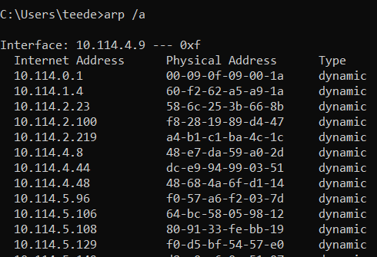

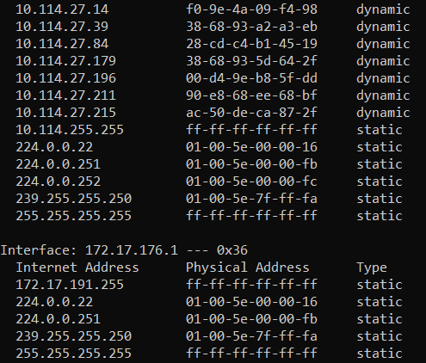

1. **netstat:** With this command we can get the statistic list of active networks (incoming and outgoing) connections and listening ports.  It helps to learn more about on open and connected port such as how to monitor and troubleshoot networking problems for system or applications. It mostly give us brief details using only numeric ip address and port numbers.

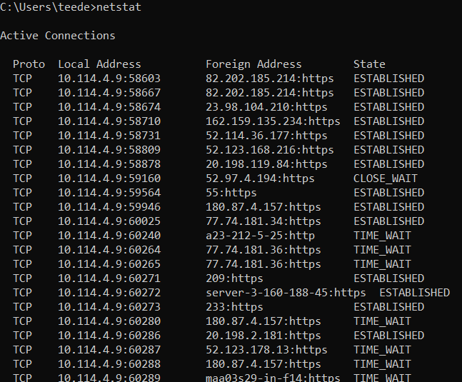

1. **systeminfo:** As it sounds, this command helps us to understand about system information by displaying a brief overview of the system configuration on a local computer or remote network systems such as   OS configuration, security information, product ID, and hardware properties (such as RAM, disk space, and network cards) and even software patches(hotfix).

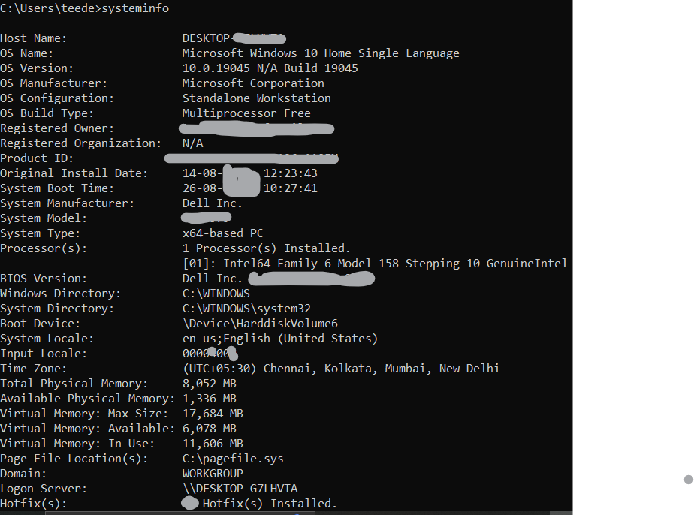

**:  AM.SC.P2CSN23008**